Appendix 1. Four main habitat types in Ujung Kulon National Park.
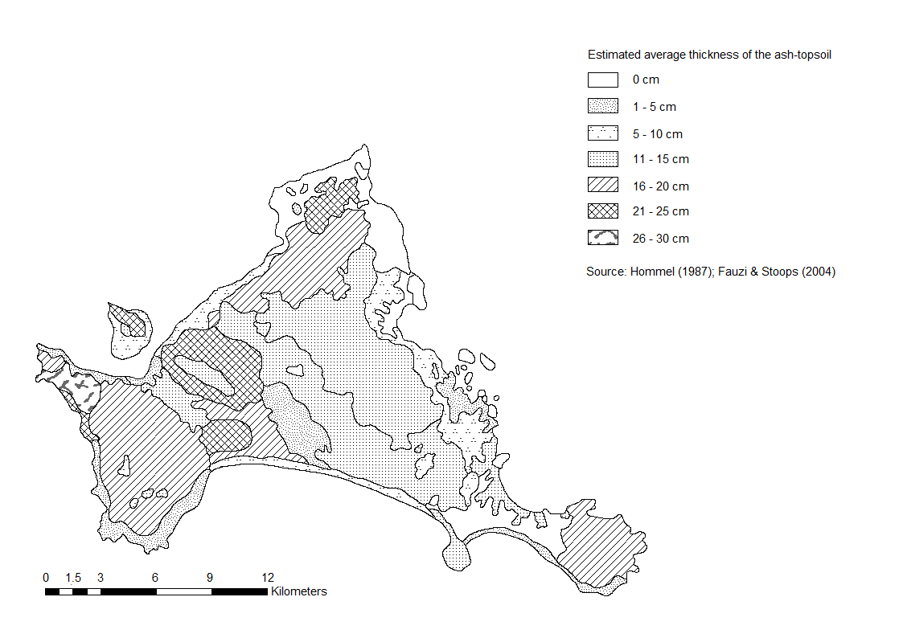

Appendix 2. Distribution of the Krakatau ash in Ujung Kulon National Park.
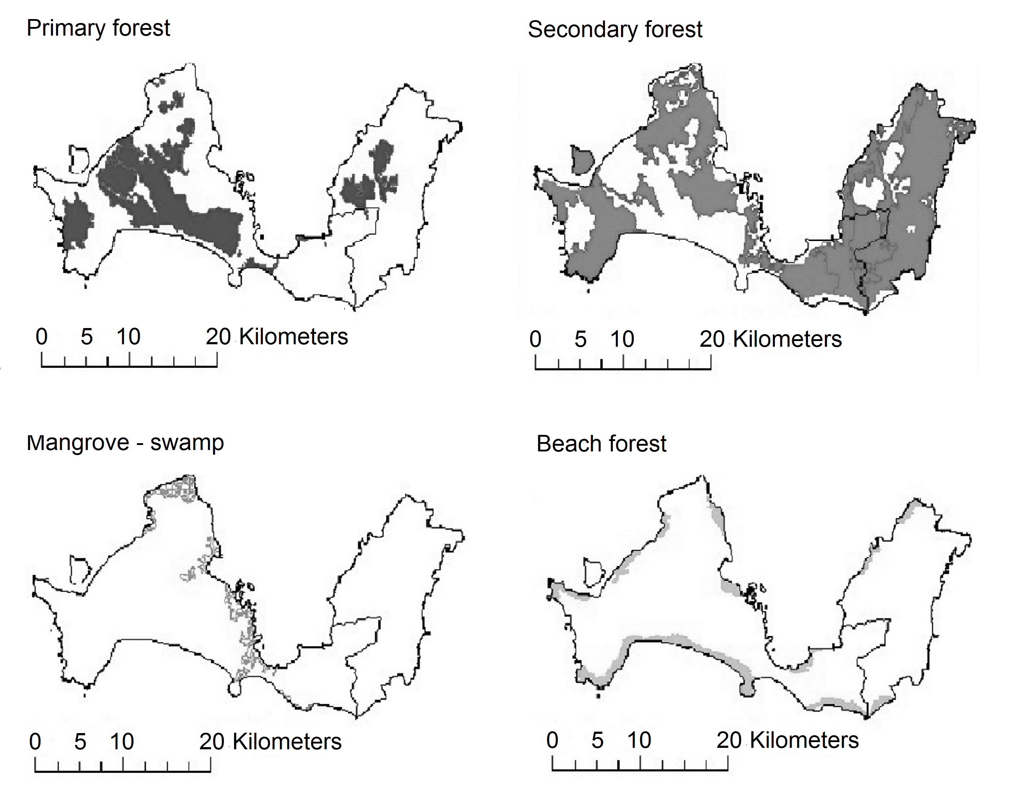

Appendix 3. Program DENSITY model selection and estimates (using Mh jacknife estimator) for Javan leopard left capture histories for camera trap study in Ujung Kulon National Park, Indonesia. Models were ranked based on Akaike Information Criterion adjusted for small sample sizes
(AICc) and AICc weights. K = number of parameters; g0 = capture probability at home range center; sigma = spatial scale over which detection declines.

Javan leopard capture history | Detection function | Models* | K | AICc | Delta AICc | Model weight | Density (Javan leopard/100 km²) | SE Density | g0 | SE g0 | Sigma (m) | SE Sigma
Wet | Negative exponential  Negative exponential  Negative exponential  Hazard rate  Negative exponential | g0[.]s[.]  g0[.]s[b]  g0[b]s[.]  g0[.]s[.]  g0[b]s[b] | 3  4  4  4  5 | 172.57  173.18  176.33  178.83  181.25 | 0.00  0.61  3.76  6.26  8.68 | 0.57  0.39  0.08  0.05  0.02 | 11.24  11.43  11.79  9.52  18.68 | 3.16  3.84  2.45  6.33  21.04 | 0.08  0.06  0.02  0.09  1.00 | 0.04  0.01  0.03  0.09  NA | 3164.52  4643.15  7852.80  3659.14  499.60 | 1412.56  1498.30  300.78  7890.82  210.64
Dry | Negative exponential  Half normal  Hazard rate  Negative exponential  Negative exponential | g0[.]s[.]  g0[.]s[.]  g0[.]s[.]  g0[.]s[b]  g0[b]s[b] | 3  3  4  4  5 | 165.36  169.16  169.25  170.37  174.84 | 0.00  3.80  3.89  5.01  9.48 | 0.69  0.23  0.12  0.08  0.01 | 12.80  11.02  10.47  11.66  12.00 | 1.99  2.49  3.28  3.50  2.34 | 0.12  0.19  0.33  0.21  0.28 | 0.06  0.23  0.30  0.14  0.32 | 1854.08  2324.94  1849.30  1560.86  2284.90 | 654.18  953.58  600.26  1612.50  1454.69
*g0[b]s[.] = behavioral effect in capture probabilities and sigma; g0[.]s[.] = Null model; g0[.]s[b] = constant capture probability and sigma varies with behavior; g0[b]s[b] = behavioral effects in g0 and sigma.

Appendix 4. The environmental variables was considered to influence Javan leopard and dholes distribution in Ujung Kulon National Park.

Environmental variables classification | Variables | Measured analysis
Geomorphology variables | Elevation, slope and distance to nearest river | The first two variables were computed on a 1 km² grid resolution by averaging information extracted from a 90 × 90 m Digital Elevation Model (DEM; Landsat 8 (http://earthexplorer.usgs.gov; http://srtm.csi.cgiar.org). Slopes were generated using slope function in ArcGIS (Jarvis et al. 2008). Distance to the nearest river was extracted in ArcGIS 10.2.2
Vegetation variables | Distance to primary and secondary forest edge, and vegetation productivity | Distance to the primary and secondary forest edge were extracted in ArcGIS 10.2.2, whilst vegetation productivity measured as the normalized difference vegetation index (NDVI, cf. Hansen et al. 2009)
Climate variables | Annual rainfall, rainfall of the wettest month, rainfall of the driest month, annual mean temperature, the maximum temperature of the warmest month, and minimum temperature of the coldest month | These variables, derived from monthly temperature and rainfall values recorded between 1950 and 2000 from a global network of climate stations, were downloaded from the WorldClim database (http://worldclim.org/bioclim). All layers were projected into WGS 1984 Zone 48 South
Human impact variables | Distance to the nearest settlement, cultivated area, and road | Distance to the nearest settlement, cultivated area, and road were extracted in ArcGIS 10.2.2

Appendix 5. Pearson’s correlations between the environmental variables used in the distribution modeling for Javan leopard and dholes in Ujung Kulon National Park.

Variables | NDVI | Elevation | Slope | Distance  to river | Distance  to primary forest edge | Distance to secondary forest edge | Distance to settlement | Distance to cultivated area | Distance  to road | Ann. m. temperature | Min. temp. of the coldest month | Max. temp. of the warmest month | Ann. rainfall | Rainfall during the wettest month | Rainfall during the driest month
NDVI | 1
Elevation | –0.009 | 1
Slope | –0.036 | 0.185** | 1
Distance to river | –0.064 | 0.213** | –0.098 | 1
Distance to primary forest edge | 0.093 | –0.529** | –0.206** | 0.014 | 1
Distance to secondary forest edge | –0.038 | 0.513** | –0.056 | 0.354** | –0.321** | 1
Distance to settlement | 0.042 | 0.538** | 0.147* | 0.038 | –0.559** | 0.231** | 1
Distance to cultivated area | 0.040 | 0.507** | 0.128* | 0.045 | –0.527** | 0.228** | 0.394** | 1
Distance to road | 0.041 | 0.509** | 0.129* | 0.045 | –0.527** | 0.228** | 0.495** | 0.089** | 1
Ann. mean temperature | –0.003 | –0.541** | –0.142* | –0.187** | 0.587** | –0.534** | –0.572** | –0.534** | –0.536** | 1
Min. temp. of the coldest month | 0.029 | –0.920** | –0.150* | –0.165** | 0.609** | –0.508** | –0.515** | –0.473** | –0.474** | 0.974** | 1
Max. temp. of the warmest month | 0.009 | 0.023** | –0.146* | –0.173** | 0.624** | –0.534** | –0.628** | –0.590** | –0.592** | 0.978** | 0.673** | 1
Ann. rainfall | –0.070 | 0.042** | 0.148* | 0.137* | –0.541** | 0.475** | 0.261** | 0.208** | 0.210** | –0.690** | –0.439** | –0.477** | 1
Rainfall during the wettest month | –0.196** | –0.253** | 0.026 | –0.122* | 0.052 | –0.158* | –0.647** | –0.675** | –0.676** | 0.246** | –0.826* | 0.282** | 0.777** | 1
Rainfall during the driest month | 0.114 | –0.932** | 0.052 | 0.227** | –0.333** | 0.500** | 0.519** | 0.496** | 0.499** | –0.546** | –0.593** | –0.751** | 0.839** | –0.601** | 1
**Correlation is significant at the 0.01 level (2-tailed).
*Correlation is significant at the 0.05 level (2-tailed).

Appendix 6. Response curves and AUC values of the MaxEnt models applied to Javan leopard (A, B) and dholes (C, D) in the wet and dry seasons.
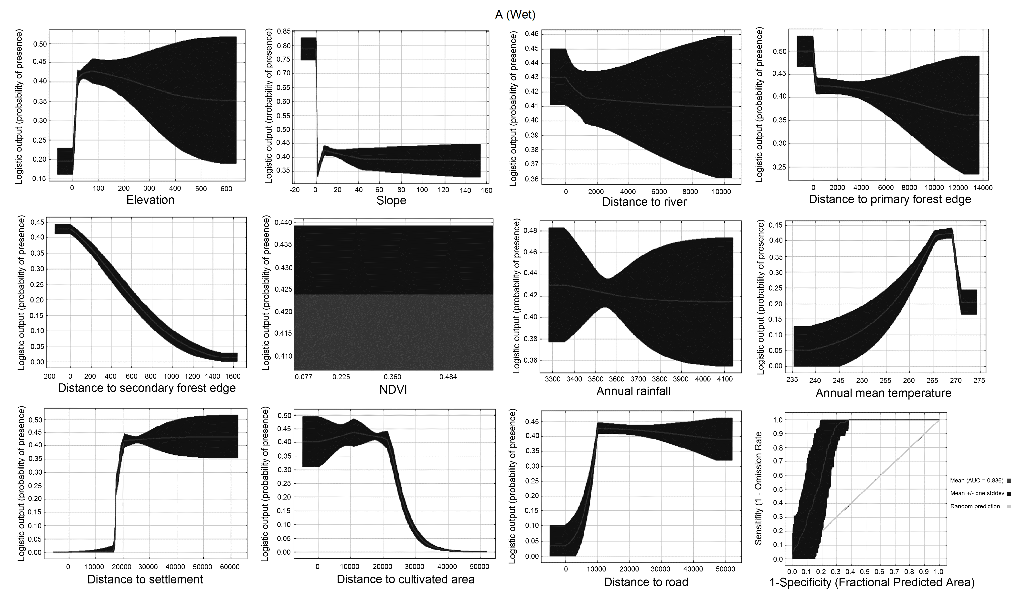

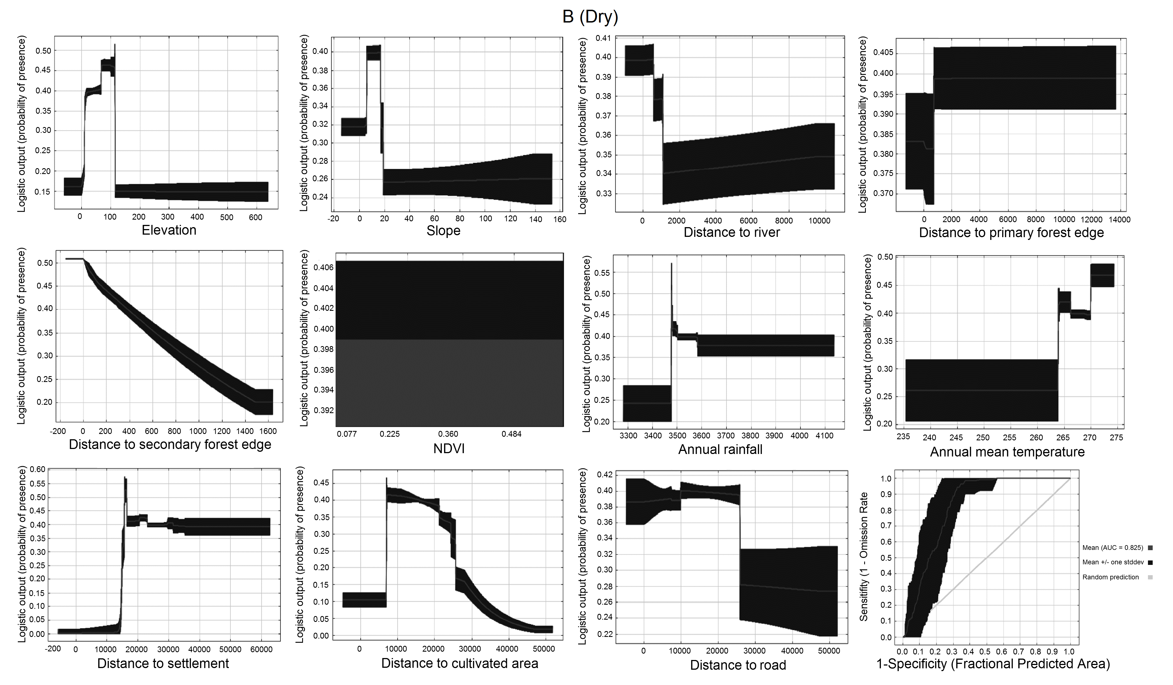

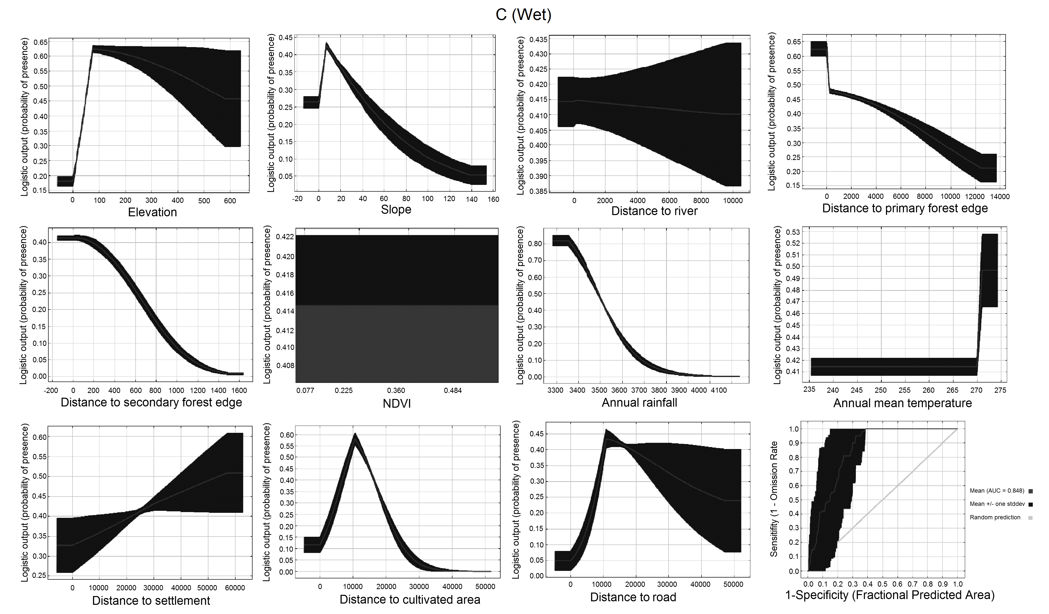

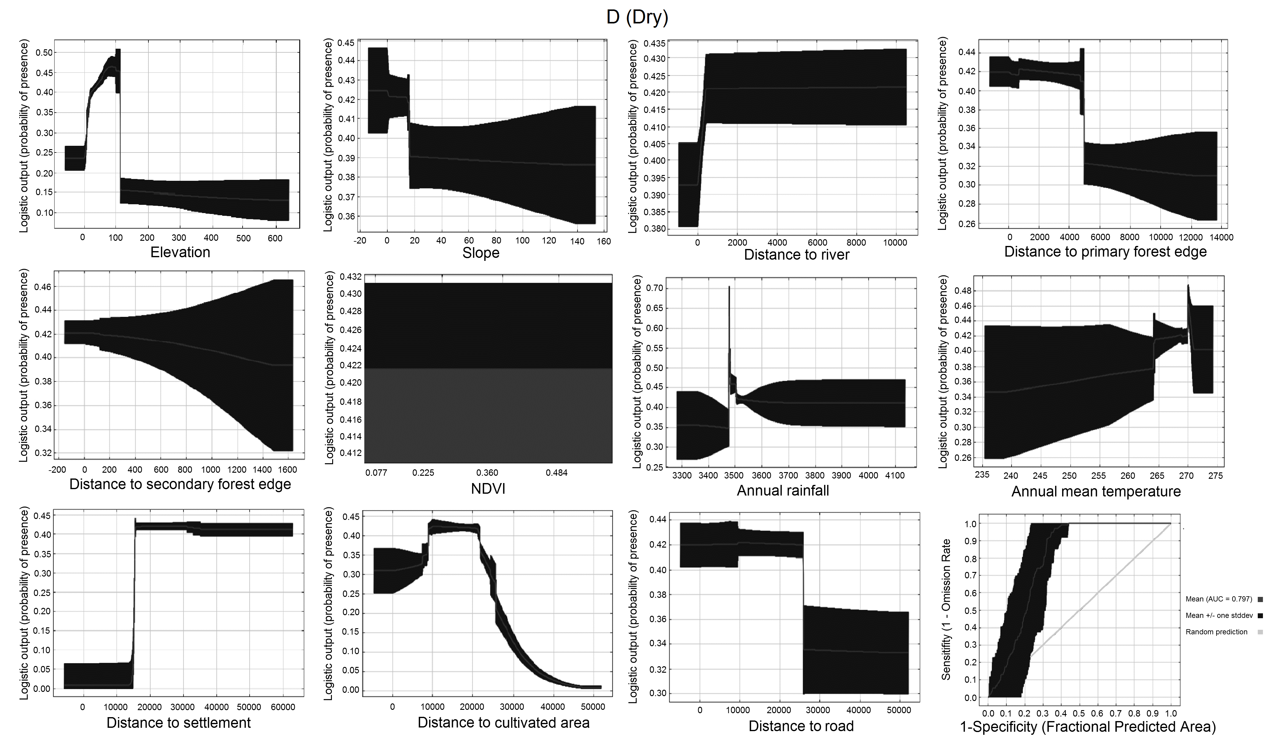
Literature
Fauzi A.I. & Stoops G. 2004: Reconstruction of a toposequence on volcanic material in the Honje Mountains, Ujung Kulon Peninsula, West Java. Catena 56: 45–66.
Hansen B.B., Herfindal I., Aanes R. et al. 2009: Functional response in habitat selection and the trade-offs between foraging niche components in a large herbivore. Oikos 118: 859e872.
Hommel P.W.F.M. 1987: Landscape-ecology of Ujung Kulon (West Java, Indonesia). PhD thesis, University of Wageningen, The Netherlands.
Jarvis A., Reuter H.I., Nelson A. & Guevara E. 2008: Hole-filled SRTM for the globe version 4, available from the CGIAR-CSI SRTM 90m Database. http://srtm.csi.cgiar.org

